**CSC 150 – Program Design Document**

**Structure Chart**

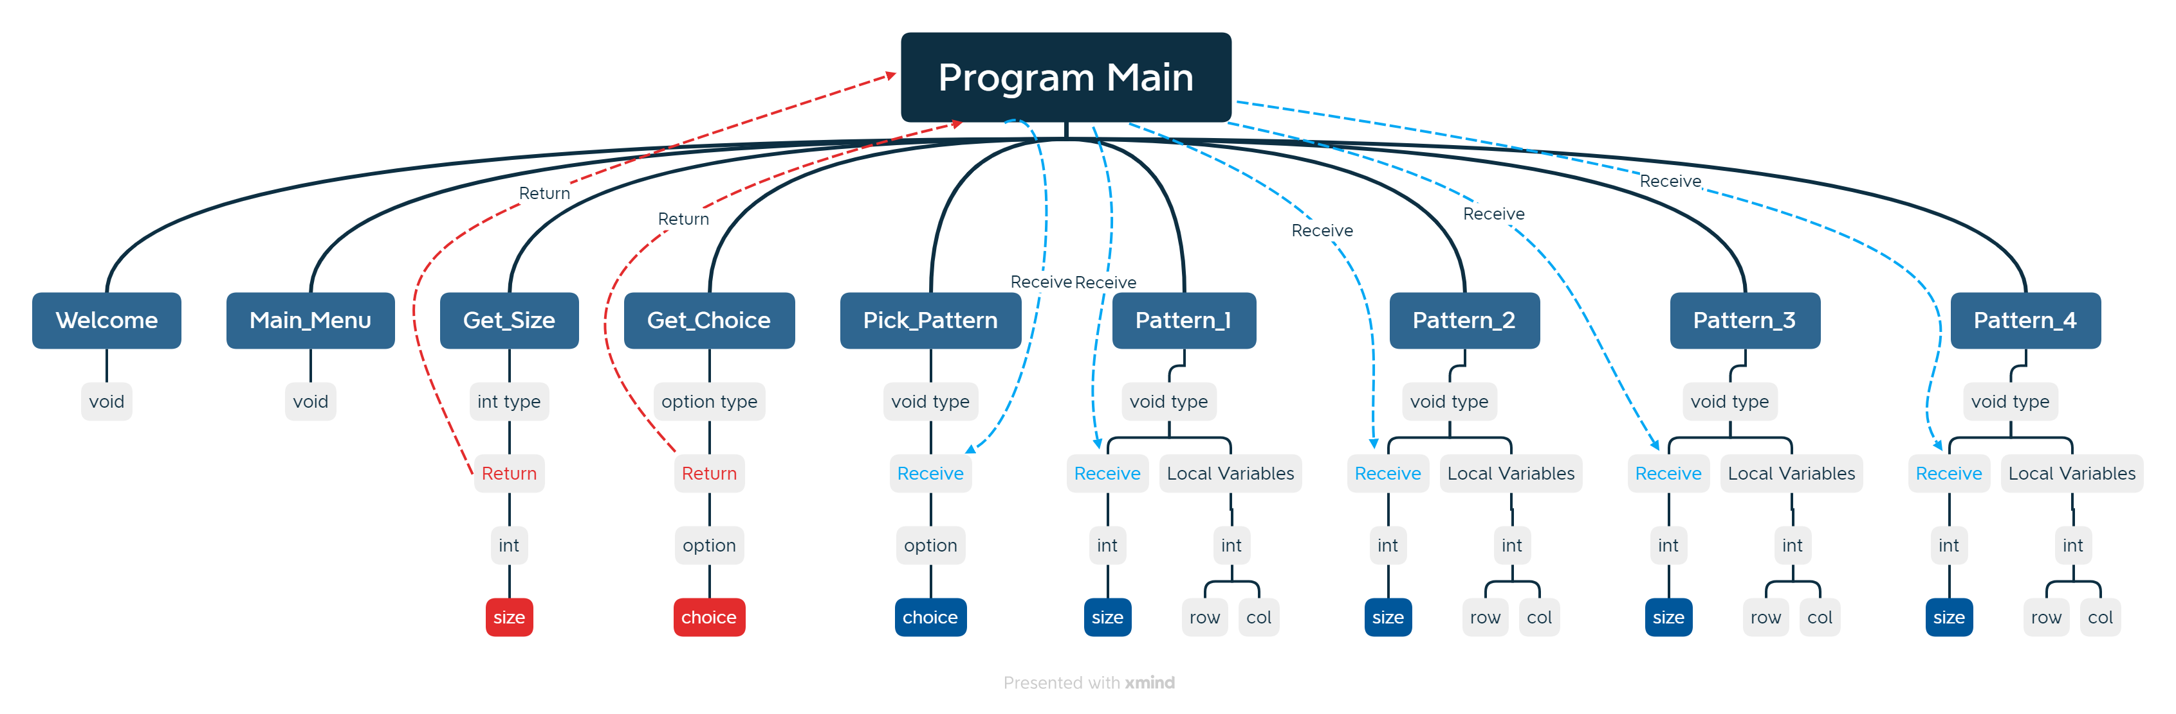

**Data Storage (defined in main)**

* int choice
  + It holds the value for the choice picked by the user
* int size
  + It holds the value for the pattern size picked by the user

**Function Design (for each function, give the function’s prototype and 1 or 2 lines describing how the function works.)**

* Main
  + Int Main ();
  + Call the other functions in the programs
* Welcome
  + void Welcome ();
  + It just prints a welcome statement telling the user about the program and its purpose and how to use it
  + Doesn’t return or take any value
* Main_Menu
  + void Main_Menu ();
  + It prints the Main_Menu, letting the user see the options.
  + Doesn’t return or take any value
* Pick_Pattern
  + void Pick_Pattern (option choice);
  + Function
    - Calls the Get_Size function
    - Calls the Get_Choice function
    - It uses the choice variable to determine which pattern will be executed
  + It comprises of switch statements
  + It takes the value from the option variable “choice”
  + It doesn’t return any value
* Get_Size
  + int Get_Size (int size);
  + It receives the size from the user and validates the input, repeating until the input is compatible
  + It doesn’t take any value
  + It returns a value in the integer variable “size”
* Get_Choice
  + option Get_Choice (option choice);
  + It receives the choice from the user and validates the input for errors
  + It doesn’t take any value
  + It returns a value in the option variable “choice”
* Pattern_1
  + void Pattern_1 (int size)
  + It prints pattern 1
  + Takes the integer variable “size”
  + It doesn’t return any value
* Pattern_2
  + void Pattern_2 (int size)
  + It prints pattern 2
  + Takes the integer variable “size”
  + It doesn’t return any value
* Pattern_3
  + void Pattern_3 (int size)
  + It prints pattern 3
  + Takes the integer variable “size”
  + It doesn’t return any value
* Pattern_4
  + void Pattern_4 (int size)
  + It prints pattern 4
  + Takes the integer variable “size”
  + It doesn’t return any value